**Shri Ramdeobaba College of Engineering and Management, Nagpur**

**Department of Computer Science and Engineering**

**Session: 2024-2025**

**Fundamentals of Linux OS I Semester**

**PRACTICAL NO. 2**

**Aim: Experimentation with File system and file handling commands**

**Theory:**

# File Commands

* $ cat *filename* display the contents of file *filename*

$ cat > *filename* create a file with the name *filename*

$ cat >> *filename* append into the file *filename*

* $ touch *filename* create an empty file
* $ more *filename* display screenful content of the file;

press space bar to scroll and ctrl d to quit

* $ less *filename* same as more but also allows to move

backward and forward; press Ctrl **B** for

backward and space bar for forward

* $ cp *file1 file2* copy file1 to file2, overwrite old file2 if it

exists

* $ mv *file1 file2* move/rename file1 to file2, overwrite old

file2 if it exists, move file1 to file2 if file2 is

a directory

* $ rm *filenames* remove filenames

options : -i asks for confirmation before deleting the file

* $ ls list names of all files in current directory

options: -l list more information about each file

-**a** list all files, including hidden ones

-t list in time order, most recent first

-u list by time last used

-r list in reverse order

* $ ls *filenames* list only the named files
* $ wc *filename* count lines, words, and characters for each

file

options : -l count lines

-w count words

-c count characters

# Directory Commands

* $ pwd print current working directory
* $ mkdir *dirname* creates a directory
* $ cd *dirname* go to the directory
* $ cd go to home directory
* $ cd .. moves up one level in file system
* $ rmdir *dirname* removes the empty directory
* $ rm –r *dirname* recursively deletes the entire contents of the

directory as well as the directory itself

# Miscellaneous Commands

* $ grep *pattern file* display lines matching pattern

options : -v display lines not matching pattern

-i ignore case

-l display filenames instead of lines

-n prefix each line of output with line number

-x select only those matches that exactly match

the whole line

* $ sort *filname* sort files alphabetically by line

options : -r reverse normal order

-n sort in numerical order

-f fold upper and lower case together

$ tail *filename* display last 10 lines of file

options : -n display last n lines of file

* $ head *filename* display first 10 lines of file

options : -n display first n lines of file

* $ cmp *file1 file2* display location of first difference
* $ diff *file1 file2* display all differences between files

**EXPERIMENTATION:**

1. What is the purpose of blue and white color in ls command execution.
2. Display your current directory.
3. List all the files (including hidden files) in your home directory
4. Go to path /home/<your username>
5. Create directory structure as follows

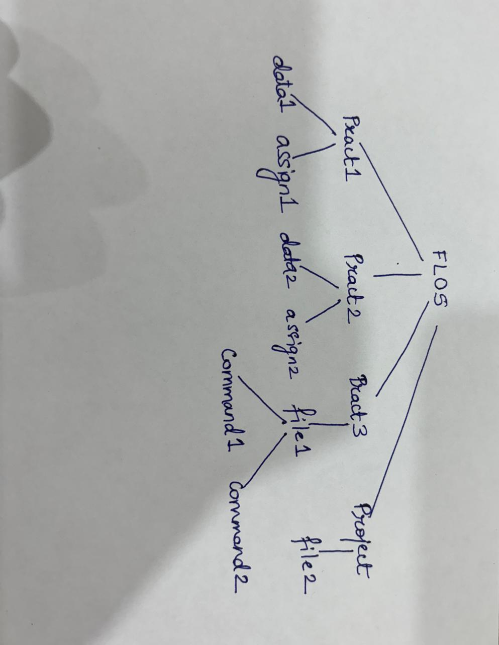

1. Do as directed:
2. Change directory to FLOS
3. Change directory to file1 using single command
4. Go back to immediate parent directory from file 1
5. Delete the directory file1
6. Show the contents of pract3
7. Create an empty file (file1.txt) in data1 directory
8. Write student names in file1.txt (one name per line)- Also write the name “Aryan” 5 times.
9. Display the count of lines, words, and characters in file1.txt
10. Copy all the contents of file1 to file2 (let file 2 be in the same directory)
11. Rename file2 to file3
12. Display the contents of file3 using different methods- display entire content, display last 3 lines, display first 3 lines
13. Delete file1.txt
14. Display student names alphabetically (from file3.txt)
15. Display the count of occurrence of “Aryan” in file3.txt using grep command
16. Create a file (file4.txt) in data2 directory with numbers and display sorted numbers in reverse.